# Rubik's Cube

## Features

* The simulator should display a three-dimensional model of a 3x3x3 Rubik’s Cube.
* It should allow a user to rotate the elements of a cube in a way that mimics a real Cube’s possible motions.
* You do not need to 'solve' the cube, just allow users to press keys to simulate the realistic rotation of Cube's component parts.
* Your application should offer a user interface to enable users to control the rotation of the Cube’s various elements.
* The Cube should be divided into appropriate elements, and each of these should be capable of rotating in a realistic manner.

## Hex Values for Colours

|  |  |  |  |
| --- | --- | --- | --- |
| **Rubik's Cube** | | | |
| Blue | #0000FF | rgb: (0,0,255) | hsl:(240,100%,50%,0.7) |
| White | #FFFFFF | rgb: (255,255,255) | hsl: (0,100%,50%,0) |
| Yellow | #FFFF00 | rgb: (255,255,0) | hsl: (60,100%,50%,0.7) |
| Green | #008000 | rgb: (0,128,0) | hsl: (120, 100%, 25%) |
| Orange | #FFA500 | rgb: (255,165,0) | hsl: (39, 100%, 50%) |
| Red | #FF0000 | rgb: (255,0,0) | hsl: (0, 100%, 50%) |

## Cube Dimensions

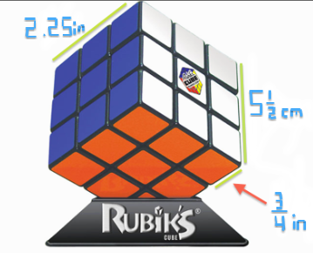

## Transformations

A cube rotation should always affect a row of 3 cubies.

One move should be a 90 degree rotation.

For each side, there should be 8 possible moves:

Left column (up, down) : W, S keys

Right column (up, down) : T, G keys

Top row (left, right) : E, R keys

Bottom row (left, right) : D, F keys

You do not move the center.

Then maybe directional arrows to rotate the whole cube. Some other controls for zooming in and out.

## Sketches